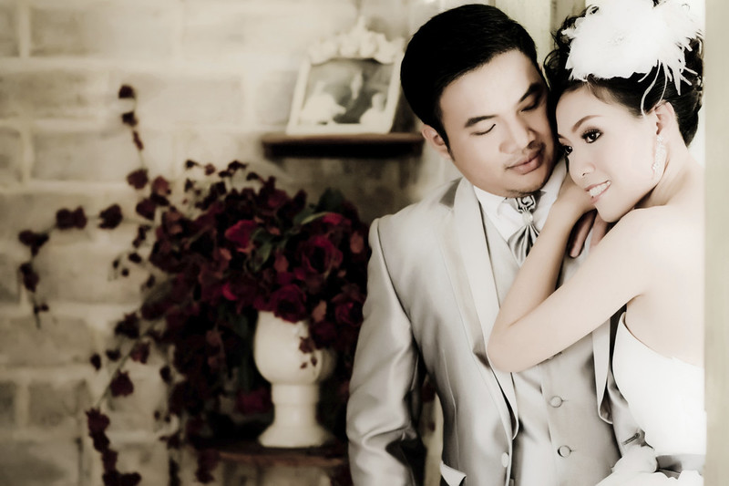“I originally approached Pixelford Photography to shoot engagement photos for me and my wife. Simon and Rupert sat down with us to discuss our every want and need. When the day of the shoot finally came, every detail was immaculately prepared. When we arrived at our location, there was a canopy and chair for us to rest under, out of the sun, during scene and lighting changes. My wife cried such happy tears on the day we first saw our wedding photos. They were so vivid, it felt like we were back in the moment. We highly recommend the personable and talented Pixelford photographers for capturing anyone’s wedding day!

*Jerry and Karen Day*

Pixelford Photography offers a wide range of services from personal to commercial. Learn more about the services we offer below, get to know our process and our pricing models, and contact us to get started!

### **Wedding portraits**

We’ve captured portraits for over 600 wedding couples and their families. Our team of photographers, led by Simon Pixelford, knows what it takes to masterfully capture the beauty and emotions of your wedding – resulting in treasured memories that last a lifetime. We’ve photographed weddings all around the world for everyday, wonderful people, as well as high profile celebrities. From covering a parachute-jumping ceremony to an African safari wedding to the more traditional wedding – we literally have done it all.

### **Wedding event photography**

Why stop shooting after the portraits and ceremony are over, when our photographers can capture the celebration of music, dancing, karaoke, or whatever you have planned for your special day? We send out a larger, or second, photography crew to shoot documentary-style images the whole night through. Capture Aunt Jane doing the Macarena, Cousin Augustus playing fiddle in the band, and your friends’ laughter and cheer, to remind you of the impact your wedding had on everyone.

## **Studio and location portraits including:**

### **Baby**

Babies grow so fast and every day they reach a new milestone. Wouldn’t it be wonderful if you could freeze those moments in time? Our baby photographers will document your child’s development over the first 16 months, in five sessions, if you select our Grow Baby GrowTM package. Of course, if you’d prefer just a single portrait session, to capture your baby’s unique personality and charm, we offer those, as well.

### **Engagement**

Tell the world about your wonderful news through our exquisite engagement portraits. Shout it from the top of a mountain or whisper it from your own backyard. No matter what your style, our skilled photographers will capture your engagement, your way.

### **Family**

What would a home be without cherished memories of family? Photographing families is a precious art to us, and we’re honored to meet so many wonderful families each year to help tell their story in pictures. In fact, we spend so many intimate moments with families, that we’ve developed lasting friendships with many of them.

### **Model and actor headshots**

Showbiz is a competitive field, and we’re not fibbing when we by tell you that you’ll go nowhere fast without honest, engaging, and flattering headshots. Fortunately, Simon has world-class experience photographing some of the top models and actors of our time, and our team has learned the tricks of the trade from his caring and guiding mentorship. Trust your face in our hands, and there’s no limit to what you might be able to accomplish.

## **Commercial photography including:**

### **Lifestyle**

The modern world is amusing, engaging, and ever-changing, and our photographers feast on the visual allure of today’s culture. Simon is a master of lifestyle photography, and is available for special assignments in this genre, including magazine features, print advertisements, and much more.

### **Fashion**

Simon started photographing fashion as a child, and his keen interest drew all the women in the family who wanted beautiful photos of themselves like the ones they saw in fashion magazines. By the mere age of twenty-two, he had already photographed supermodels and covered some of the world’s most prestigious fashion events.

### **Travel**

Many photographers shoot travel images, however our team documents destinations and culture. Rather than seeing a flat image of a place – you can sense the heartbeat and soul of the destinations that we photograph. We’re available for destination shoots all around the world.